NOAA-19 / NOAA-N’

On February 6th, 2009, NOAA 19 launched off from Vandenberg Air Force Base aboard a Delta II rocket (NOAA-19,1). NOAA 19 was the last of the United States National Oceanic and Atmospheric Administration’s (NOAA) Polar Operational Environmental Satellites (POES). A series of satellites that dates to TIROS-1, the first successful low-Earth orbital weather satellite, launched on April 1st, 1960. With such an impressive history, and the combined efforts of contractor, United Launch Alliance, and manufacturer, Lockheed Martin, this satellite was one to keep an eye out for. This did not happen.

Five years and five months before launching, during a required repositioning “…the satellite slipped from the Turn-Over-Cart (TOC) and fell to the floor… The satellite sustained heavy damage…” (NOAA N-PRIME Mishap Investigation Board, 2). Repairs to the satellite costed $135 million and put the project years behind. Lockheed Martin, in order to aid the recovery efforts agreed to forfeit all profit from the project and additional took a $30 million dollar charge. The total amount of profit forfeited by Lockheed Martin was never released but it estimated to be around $223 million (Bates, Jason, 3).

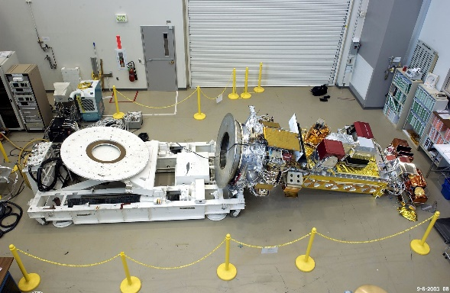

Figure NOAA-N Prime after falling over during construction

Once the NOAA N-PRIME Mishap Investigation Board had concluded their operations, the proximate cause was that; “The NOAA N-PRIME satellite fell because the LMSSC operations team failed to follow procedures to properly configure the TOC, such that the 24 bolts that were needed to secure the TOC adapter place to the TOC were not installed.” (NOAA N-PRIME Mishap Investigation Board, 2). This exact failure of procedures was detailed later in the report. While the TOC was in storage, a technician removed the 24 bolts securing the adapter plate without documenting the action, the team in change of the next repositioning failed to check the security bolds before moving the satellite. At an angle of 13 degrees of tilt, the spacecraft fell to the floor.



Figure Turn Over Cart Interfaces

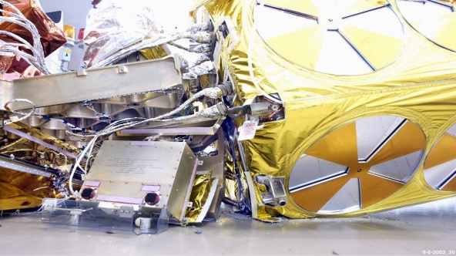

Figure NOAA N-PRIME Damages

The purpose of the repositioning was to shim the Microwave Humidity Sounder (MHS) by initially removing and replacing the instrument. MHS’s are a five-channel passive microwave radiometer, with an operational range from 89 to 190 GHz (Microwave Humidity Sounder, 4). The primary purpose of MHS’s are to study profiles of atmospheric water vapor and to provide data for cloud-clearing algorithms. This instrument was designed for a five-year mission but have proven to have a much more durable operational period. Apart from MHS’s, NOAA-19’s primary instruments include the Advanced Very High-Resolution Radiometer (AVHRR/3), High Resolution Infrared Radiation Sounder (HIRS/4), and the Advanced Microwave Sounding Unit (AMSU-A). Each of these components were designed for a three-year mission.

Prior to launch, the satellite was designated as NOAA-N’ (NOAA-N Prime), post launch it carries it current title of NOAA-19. After competition of the satellite’s hardware, it arrived at Vandenberg Air Force Base on November 4th, 2008. On January 27th, 2009 the installation of payload fairing occurred with second stage propellant fully loaded by January 31st, 2009. After two scrubbed launch attempts, the Delta II carrying NOAA 19 lifted off at 10:22:00 AM on February 6th, 2009. With a payload launch mass of 1,440 kilograms, this large satellite was well within the Delta II launch capacity of 6,100 kg to Low Earth Orbit (Delta II, 5).

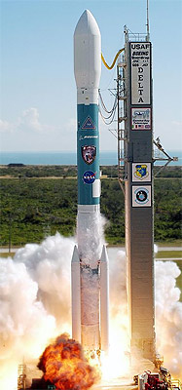

Figure Delta II 7320-10C

The NOAA Polar Operational Environmental Satellite was placed in Sun-synchronous orbit with an inclination of 98.97 degrees. The eccentricity of an orbit is a unitless amount by which an orbit around another body deviates from a perfect circle. An eccentricity of 0 results in a circle and 1 of a parabolic escape orbit. NOAA-19 has an eccentricity of 0.0013582 thus a nearly circular orbit. It’s orbit still exhibits an elliptical behavior with a Perigee altitude of 850 kilometers (530 miles) and an Apogee altitude of 869 kilometers (540 miles). NOAA-19 travels at 76,790.43 kilometers/hour (47,994.02 miles/hour) and has an orbital period of 101.99 minutes (NOAA-19,1).

After successfully reaching its operational orbit, NOAA-19 began its work as a weather satellite. The Prime Mission of NOAA-N in NASA’s words is to “improve weather forecasting and monitor environmental events around the world.” (Dunbar, Brian, 6). NOAA-19 will collect meteorological data to be transmitted to NOAA’s Satellite and Information Service. This service will the process the data for key information useful to the National Weather service for its research on long-range weather and climate forecasts. Apart from NOAA specific uses, forecasters and meteorologists worldwide will have access to its images and data.

The first images from NOAA-19’s Advanced Very High-Resolution Radiometer (AVHRR/3) Automatic Picture Transmission (APT) were taken by Fred E. Piering on February 6th, 2019 during its fourth orbit (Dunbar, Brian, 7). Piering has been a part of APT since 1971 but in this case used home build antenna and receiver. The image was received as NOAA-19 rose over the southeastern horizon above South America until it set over the northern horizon above Canada.

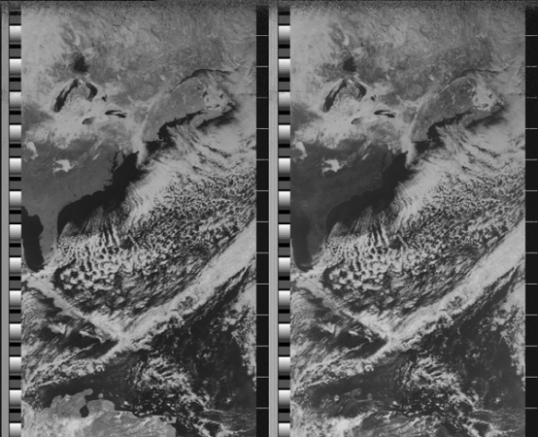

Figure First Image from NOAA-19. Image Credit: Fred Piering, Weather Satellite Hobbyist

As of February 2nd, 2020, NOAA-19 is still active, making the elapsed mission duration, 10 years, 11 moths, and 27 days. This far surpasses the planned mission duration of 2 years and reflects upon the engineering craftsmanship of its instruments and operations. The NOAA POES were scheduled to be replaced by the National Polar-orbiting Operational Environmental Satellite Systems (NPOESS), but that project was canceled.

References

1. “NOAA-19.” Wikipedia, Wikimedia Foundation, 28 Jan. 2020, en.wikipedia.org/wiki/NOAA-19.
2. NOAA N-PRIME Mishap Investigation Board. “*NOAA N-PRIME Mishap Invesitgation-Final Report”.* National Aeronautics and Space Administration. Oct. 1st 2004.
3. Bates, Jason (October 11, 2004). "Lockheed Martin Profits To Pay for NOAA N-Prime Repairs". www.space.com. Retrieved June 19, 2016
4. “Microwave Humidity Sounder.” Wikipedia, Wikimedia Foundation, 7 June 2019, en.wikipedia.org/wiki/Microwave_humidity_sounder.
5. “Delta II.” Wikipedia, Wikimedia Foundation, 2 Oct. 2019, en.wikipedia.org/wiki/Delta_II.
6. Dunbar, Brian. “NOAA-N Prime.” NASA, NASA, [www.nasa.gov/mission_pages/NOAA-N-Prime/main/index.html](http://www.nasa.gov/mission_pages/NOAA-N-Prime/main/index.html).
7. Dunbar, Brian. “First Image from NOAA-19.” NASA, NASA, www.nasa.gov/mission_pages/NOAA-N-Prime/news/NPrime_first_image.html.